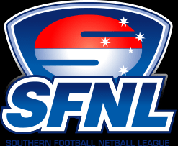
MAIN FOCUS WITH FIELD UMPIRES MARCH-APRIL-MAY

UMPIRING MARSHALL’S WAY…

LET EM PLAY FOOTBALL
PAY ALL MAJOR AND OBVIOUS FREE KICKS
TAKE APPROPRIATE ACTION WHEN REQUIRED
WITH CLEAR VOICE STRONG BODY LANGUAGE
CLEAR DECISION MAKING
TRIGGER RUNNING
MOVEMENT AT STOPPAGES
FORWARD OBSERVATION
3 UMP SYSTEM ALL UMPIRES UMPIRING
KEEPING DISTANCE FROM PLAY CDMP
TAP THRU CONSTANTLY
SETKICK CONTROL IS THE CORNERSTONE TO GOOD UMPIRING
WORK RATE IS ABOVE 80%
POSITIONING AROUND THE GROUND IN BOTH 2 AND 3 UMP SYSTEMS
SPIRIT OF THE LAWS
GOOD MATCH MANAGEMENT
TEAM FIRST MENTALITY

1%’S

BOUNCING
AWARENESS
50M PENALTY WHEN REQUIRED AND OR REPORTS.
ZERO TOLERANCE TO UMPIRE ABUSE FROM PLAYERS AND BENCH
ZERO TOLERANCE TO UMFPIRE CONTACT
OUT OF ZONE UMPIRING TO DISCUSS
MOVING PLAYERS ON IN SENIOR FOOTBALL AFTER 7 SECONDS 10 SEC RESERVES AND 19S.

TO BE CONTINUED……… PETE 0412 225830

