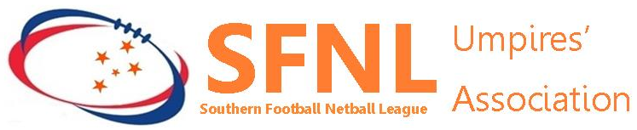

SFNLUA Social Media & Online Engagement Policy

Membership Behavioural standards and expectations

In accordance with the SFNLUA Statement of Purpose & Values and SFNLUA Rules, SFNLUA members are expected to conduct themselves, both during and outside umpiring appointed duties, in a manner that protects their reputation and the reputation of the SFNLUA & SFNL. This applies to member’s use of personal social media sites.

In line with this, members are to apply the following when using social media in a personal capacity:

- Adhere to the Terms and Conditions of the relevant social media platform/website and any other applicable laws, including copyright, privacy, defamation, discrimination and harassment.

- Do not make any comment about the Director of Umpiring or staff appointed to the Umpiring Department SFNL or SFNLUA executive or administration, except in the appropriate forums.
- Do not post or endorse any obscene, violent, discriminatory, vilifying, defamatory, offensive, insulting, threatening, harassing words, images or sounds.
- Do not publish material that might otherwise cause damage to the SFNL or SFNLUA reputation or bring them in to disrepute.

Ensure comments are respectful of the community in which they are interacting online

Security, privacy and reputation management

Members should take care when considering what information to place on their or the SFNLUA social media sites. Once information is placed online it is in the public domain, is difficult to control and remove and can be easily forwarded to others. In many cases, once the information is uploaded, it is owned by the site and can be used without the knowledge or permission of the person who posted it.

Information may also be accessed by an unintended audience and/or for unintended purposes, or you could be associated with information, people or groups that you do not know or support.

With this in mind, members should be mindful about:

- Using appropriate security/privacy settings
- Revealing details that may enable unsolicited contact

References:
Southern Football League Umpires’ Association – Statement of Purpose & Values
Southern Football League Umpires’ Association – Rules – section 3.14 -5.1

